TASK 6 – Evaluate the Cost of System Calls
Course: CSA04 – Operating Systems
Bloom's Level: K5 – Evaluate
1. Why does each system call cost much more than an ordinary function call?
A system call is a mechanism through which a user program requests services from the operating system kernel. Examples include read(), write(), open() and close().
An ordinary function call executes within the same program and generally does not require switching between operating-system execution modes. However, a system call requires a transition from user mode to kernel mode.
Reasons why system calls are more expensive:
- Mode switching: The processor switches from user mode to kernel mode to execute the requested operation.
- Parameter validation: The operating system checks the arguments, memory addresses and permissions before performing the operation.
- Context management: The processor saves the necessary execution state and prepares to execute kernel instructions.
- Kernel execution: The operating system performs the requested operation, such as reading data from a file or writing data to storage.
- Returning to user mode: After completing the operation, the processor restores the program's execution state and returns control to the application.
Example:
If a program reads a file one byte at a time, it may require thousands of read() system calls. Each call introduces additional overhead. Instead, reading multiple bytes in a single call reduces the number of transitions.
Therefore, system calls generally cost more than ordinary function calls. Reducing unnecessary system calls improves overall system performance.
2. How does buffer size change the number of read() and write() calls when the database copies a file?
Buffer size determines how many bytes are transferred during each read or write operation. When a program copies a file, it reads data into a temporary memory buffer and writes that data into another file.
A smaller buffer requires more operations to copy the entire file, whereas a larger buffer transfers more data in each operation.
Example:
Consider a database backup program that copies a file of 10,000 bytes.
Buffer size | Number of read() calls | Explanation
1 byte | 10,001 | 10,000 data reads + 1 EOF read
512 bytes | 21 | 20 data reads + 1 EOF read
4096 bytes | 4 | 3 data reads + 1 EOF read

3. How does library buffering (fread, fwrite) reduce the number of system calls?
Library buffering is a technique used by standard C library functions to reduce frequent interactions between an application and the operating system.
Functions such as fread() and fwrite() use an internal memory buffer to collect or retrieve data in blocks.
Working of fread():
- The fread() function reads a block of data from a file into a memory buffer.
- Instead of requesting one byte at a time from the operating system, it can retrieve multiple bytes together.
- If the internal buffer already contains the required data, additional system calls may not be necessary immediately.
Working of fwrite():
- The fwrite() function collects data in an internal output buffer.
- When the buffer becomes full or is flushed, the library sends the data to the operating system using write operations.
- This reduces the frequency of system calls.
Example:
Suppose a program needs to copy a 10,000-byte file.
Without effective buffering, the program might perform thousands of small read and write operations.
With library buffering, data is collected and transferred in larger blocks, reducing the number of operating-system interactions.
Advantages of library buffering:
- Reduces the number of system calls.
- Minimizes user-mode and kernel-mode transitions.
- Improves file-reading and file-writing performance.
- Reduces unnecessary CPU overhead.
- Makes large file operations more efficient.
Therefore, fread() and fwrite() improve file-processing efficiency by using internal buffers to reduce frequent system calls.
4. What is the best buffer size for the hospital's backup program, using your measurements?
A hospital backup program must copy important data such as patient records, medical reports, laboratory results and database files efficiently.
The buffer size plays an important role in determining the performance of the backup program. A suitable buffer size reduces system-call overhead and improves file-copying speed.
Based on the experiment using a 10,000-byte test file, the following results were obtained:
Buffer size | Read calls | Performance
1 byte | 10,001 | Very low efficiency
512 bytes | 21 | Moderate efficiency
4096 bytes | 4 | High efficiency

5. Alternative Concept and Complexity Analysis – Memory-Mapped Files (mmap)
Memory-mapped files provide an alternative method for accessing files without repeatedly using the read() and write() system calls.
The mmap() system call maps a file or a portion of a file into the virtual address space of a process. The application can then access file contents using normal memory operations.
Working of mmap():
- Open the source file using open().
- Obtain the file size using fstat().
- Map the source file into memory using mmap().
- Create or open the destination file and set its required size.
- Map the destination file into memory.
- Copy the contents from the source mapping to the destination mapping using memory operations such as memcpy().
- Use msync() when synchronization with storage is required.
- Release the mappings using munmap() and close the files.
Comparison between read()/write() and mmap():
Factor | read() and write() | mmap()
System calls | Repeated calls for each buffer | A few mapping-related calls
Data transfer | Uses an intermediate user-space buffer | Accesses mapped file pages directly
Memory usage | Uses a fixed-size buffer | Uses virtual address space for mapping
Large files | Can process files in blocks | Can map large files in smaller sections
Performance | Depends on buffer size | Can be efficient for suitable workloads

6. Evidence – Measured System-Call Counts and Times
The experiment compares three buffer sizes to identify their effect on file-copying performance.
Experimental observations:
Buffer size | Expected read calls | Execution time
1 byte | 10,001 | To be measured
512 bytes | 21 | To be measured
4096 bytes | 4 | To be measured
The number of calls is calculated from the 10,000-byte test file. Execution time must be recorded by running the program on Linux.
Observation:
The 1-byte buffer requires the highest number of read operations, whereas the 4096-byte buffer requires the lowest number. This demonstrates that larger buffers reduce the number of system calls.
Note: If you execute the alternative Dev-C++ program using fread() and fwrite(), it counts successful library read blocks, not actual Linux system calls. Do not present those counts as strace measurements.
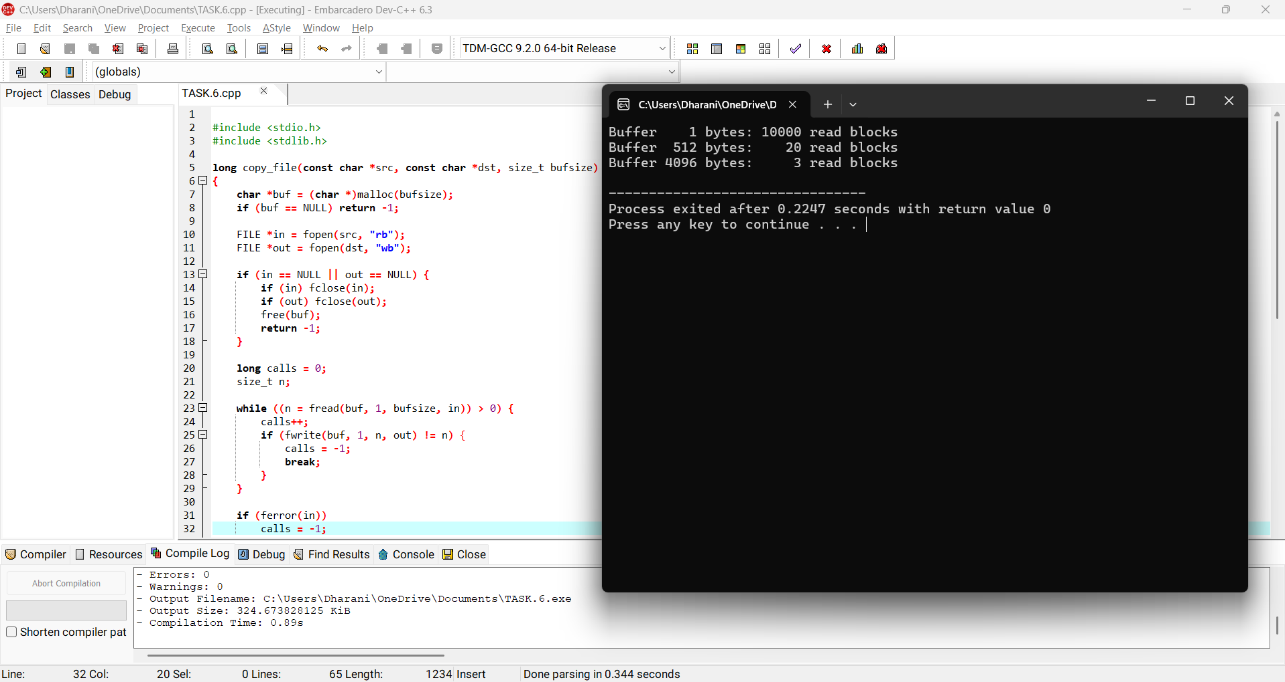

7. Overall Result
The cost of system calls was evaluated by studying the effect of buffer size on file-copying performance. The experiment demonstrated that smaller buffers require more read() and write() operations, resulting in higher system-call overhead. Library buffering using fread() and fwrite() reduces frequent operating-system interactions by transferring data in blocks. Memory-mapped files provide an alternative approach by mapping file contents into virtual memory and reducing explicit read and write operations.

